Python Assignments

1. Grade Checker

Take a score as input and print the grade based on the following:

90+ : "A"

80-89 : "B"

70-79 : "C"

60-69 : "D"

Below 60 : "F"

here we used a basic if else statement to carry out marks and all.

Solution –

print("Check the grade you recieved!\n")

score = int(input("Enter your score:\n"))

if score>=90:

    print("A grade")

elif score>=80 and score<=89:

    print("B grade")

elif score>=70 and score<=79:

    print("C grade")

elif score>=60 and score<=69:

    print("D grade")

elif score<=60:

    print("F grade")

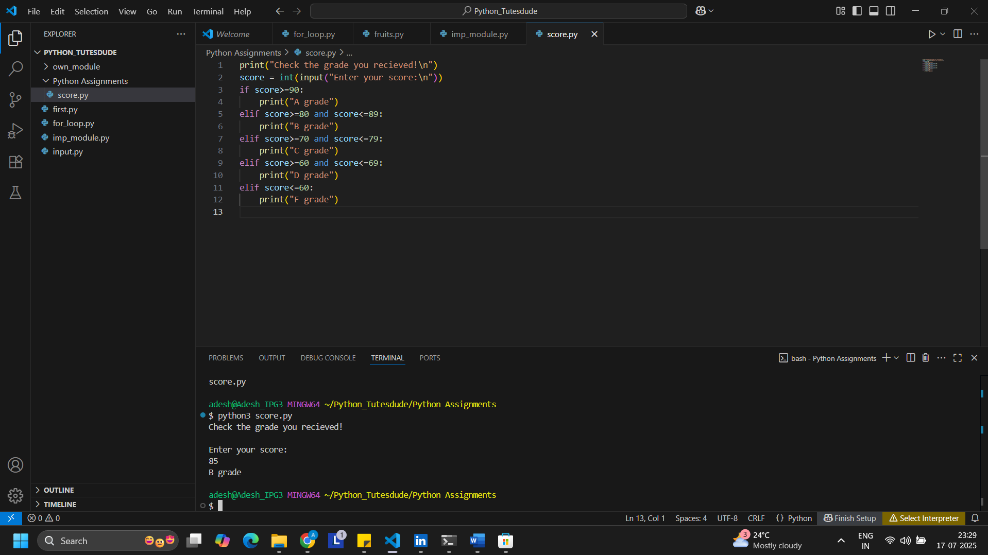

2. Student Grades

Create a dictionary where the keys are student names and the values are their grades. Allow the user to:

Add a new student and grade.

Update an existing student’s grade.

Print all student grades.

Used dictionary and basic operations. Using if else:

Solution –

#dictionary containing student's name with grade

student_grade = {'Ram':'A', 'Shyam':'B', 'Ganesh':'D', 'Krishna':'C', 'Rakesh':'F'}

#print the dictionary

print (student_grade)

# Get information from viewer about new student and its grade

name = input("Enter the new student's name:\n")

grade = input("Enter " + name + "'s grade:\n")

#insert the new student into the existing dictionary

#student_grade.update({name:grade})

student_grade[name]=grade

#print the dictionary

print (student_grade)

#Ask user to update existing student's grade

existing_user=input("Enter the student's name which you want to update from the above list:\n")

if existing_user in student_grade:

    #Changing the grade of the student

    print("Student exists in the dictionary! Please proceed")

    changed_grade=input("Enter the correct grade:\n")

    student_grade[existing_user] = changed_grade

else:

    print("Student does not exists for modification!")

#print the dictionary

print (student_grade)

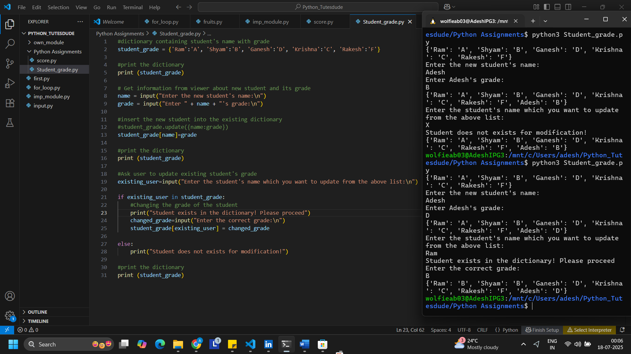

3. Write to a File

Write a program to create a text file and write some content to it.

Using file functions like write and open.

Solution –

#creates file object with new file as display with write mode

#File will be created in the same folder

file_obj = open("display.txt",'w')

#writting content to the file

file_obj.write("Hello this is my first file.\n")

#Wrote 2nd line to the file

file_obj.write("This is 2nd line\n")

#closed the file

file_obj.close()

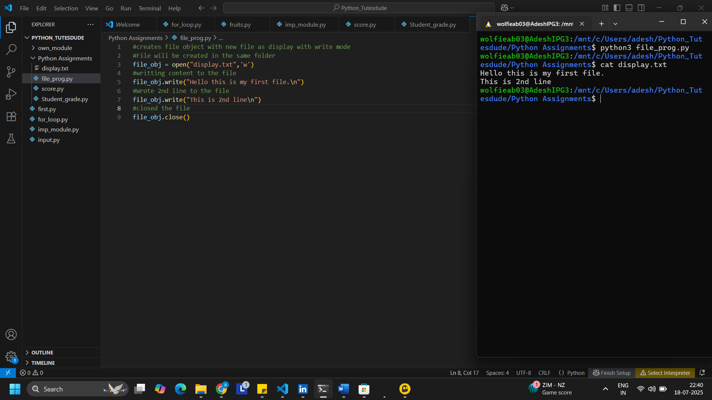

4. Read from a File

We used open in read mode and file.read to read and print to display.

Solution –

#Open the file in read mode

file_obj = open("display.txt","r")

#read the contents of the file

print(file_obj.read())

#close the file

file_obj.close()

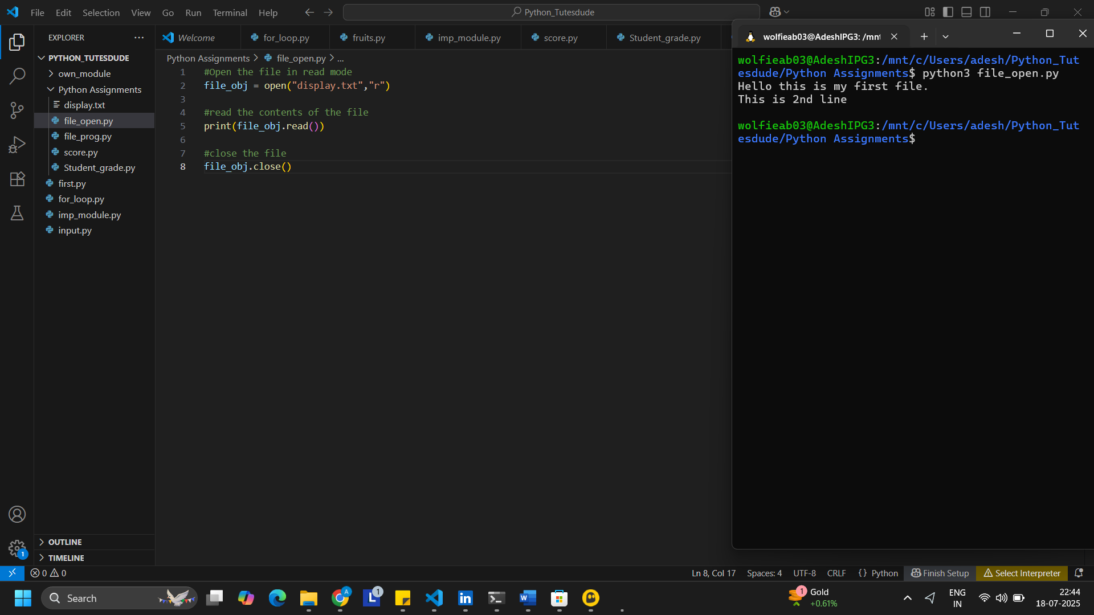

Github - https://github.com/WolfieAB03/Devops_tutedude